**Content guidelines for Amazon Connect integrations**

The AWS Quick Start team publishes a landing page for each Amazon Connect integration, as shown in the following screen illustration. In addition, the Amazon Connect Integration portal page (<https://aws.amazon.com/quickstart/connect/>) briefly describes and links to each integration.

The landing page has three main components:

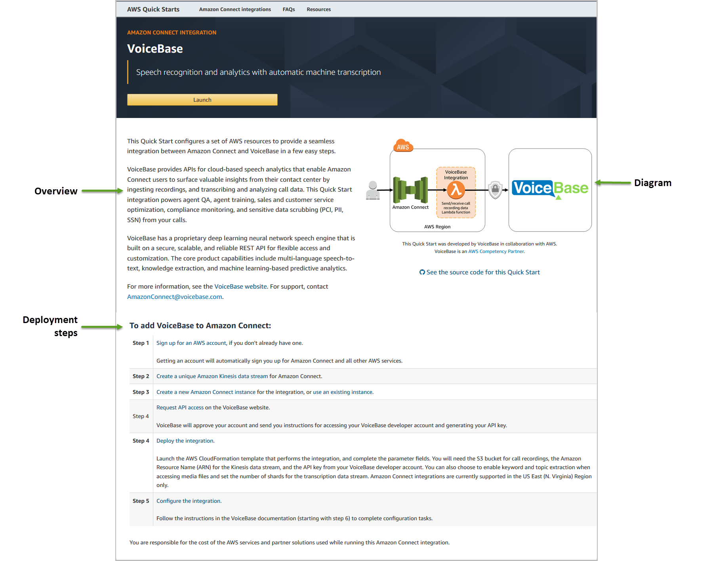

We ask that you send us the following content for the landing page:

* A **brief overview** that describes your integration in **technical terms**, including the functionality and the benefits of the integration with Amazon Connect.
  + Stay away from buzzwords and marketing jargon.
  + Try to provide clear, concise, grammatically correct text. AWS technical writers will review and edit your content, but providing a clean copy will expedite the publishing process.
  + Keep the overview fairly short, e.g., 3-4 paragraphs.
  + Provide this information in a Word file, if possible, to simplify revision tracking and commenting.
* A description of the **steps the user needs to follow** to deploy the integration.
  + Keep the steps simple.
  + If you need to cover pre-deployment or post-deployment configuration details or testing/usage instructions, provide that information on your website and link to it from your step-by-step instructions. (See the last section for details.)
  + Provide this information in a Word file if possible. It’s fine to use the same Word file for the overview and the steps.
  + Include the following standard steps in your instructions:

1. [Sign up for an AWS account](http://docs.aws.amazon.com/connect/latest/adminguide/gettingstarted.html#sign-up-for-aws), if you don’t already have one.

Getting an account will automatically sign you up for Amazon Connect and all other AWS services.

1. [Create a new Amazon Connect instance](http://docs.aws.amazon.com/connect/latest/adminguide/gettingstarted.html#launch-contact-center) for the integration, or [use an existing instance](https://console.aws.amazon.com/connect/).
2. Get a subscription to … [include instructions for subscribing to your Marketplace AMI or software].
3. Deploy the integration.

Complete the parameter fields. Deployment takes just a few minutes. Amazon Connect integrations are currently supported in the US East (N. Virginia) Region only.

1. Configure the integration.

Follow the instructions in the *… Integration Guide* to complete configuration tasks. [Provide a link to a document on your website that describes post-deployment tasks, if any.]

AWS technical writers will review the content you’ve provided, and will send you their edits and any comments or questions. Please review the edited text and resolve questions so we can finalize the content. **Keep revision tracking enabled for any additions or changes.**

In addition, please provide:

* An **architecture diagram**. Use the following PowerPoint template we’ve provided and edit it for your integration:
  + For AWS Lambda-based integrations: <https://github.com/jayyeras/amazon-connect-integration-guide/blob/master/doc_source/templates/AC_Integration_Template.pptx>

Include a logo or illustration of the technology you’re integrating in the box on the right, and edit the labels in the “Your integration” box as appropriate.

* + For more complex reference architectures: <https://github.com/jayyeras/amazon-connect-integration-guide/blob/master/doc_source/templates/AC_Integration_Template_Ref_Archs.pptx>

Update the box labeled “Data Streaming integration” with the services and flows for your integration. Use the service icons and other graphics from the PowerPoint template provided on the [AWS Simple Icons for Architecture Diagrams](https://aws.amazon.com/architecture/icons/) webpage.

If the Amazon Connect integration requires pre-deployment or post-deployment procedures that can’t be described in a few simple steps, consider publishing **a separate document on your website** with this information.

* Call the document an *integration guide* or *configuration guide*. Don’t call it a *deployment guide*.
* Do not include any AWS branding or logos in your guide.
* Link to the AWS landing page for deployment instructions.
* If you decide to repeat the deployment steps, make sure that the information is consistent with the information you’ve provided for the landing page, to avoid confusing the reader.
* AWS technical writers won’t be able to edit your document, but we recommend that you review it carefully for accuracy and clarity.
* Provide the URL for the document so we can link to it from the landing page.